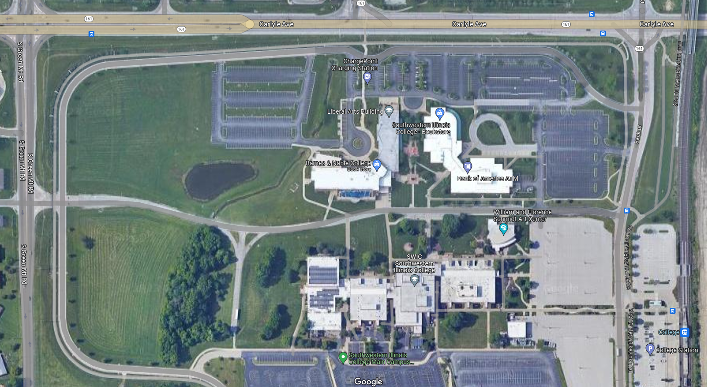Map of Southwestern Illinois College

ISSRT Southern Conference November 4, 2023

Liberal Arts Building Theater, Room 1370

Enter here 🡪

Parking